**Name** :- Patil Pallavi Kalyansing.

**Roll No** :- 88

**Assingment N**o :- 1.2

**Assingment** :- Develop program to learn different types of structure(list, dictionary, tuples) in python

(Repetition statement).

* **for loop using range****for** x **in** range(5):  
   print(x)
* **Output:-**

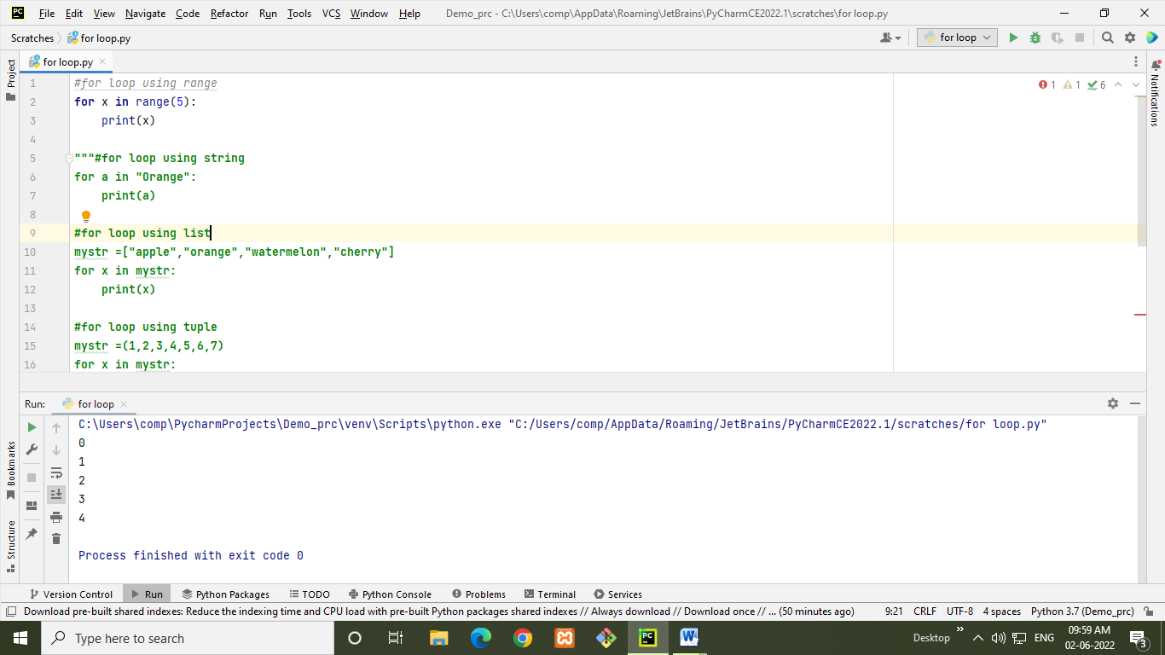

* **for loop using string**

**for** a **in "Orange"**:  
 print(a)

* **Output:-** 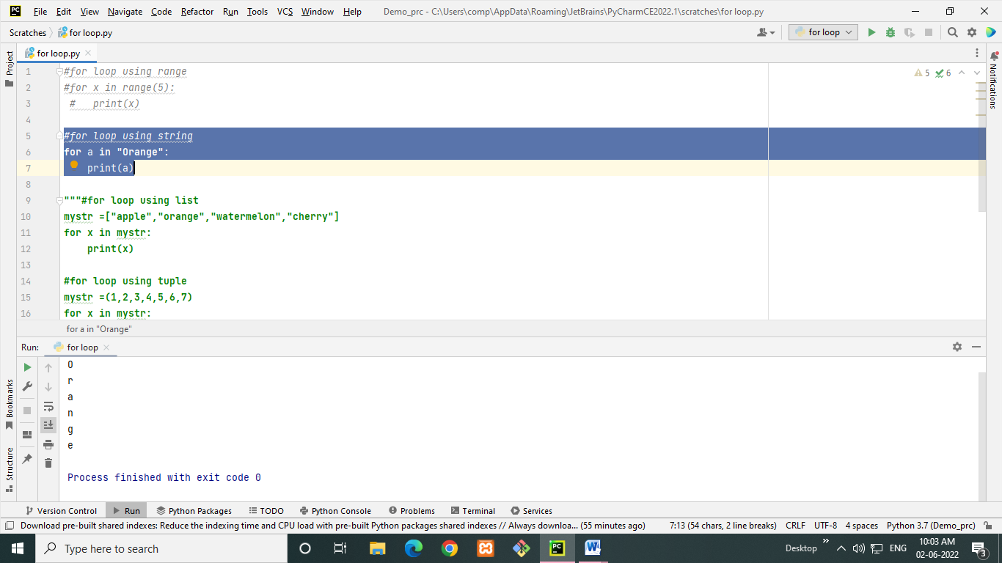
* **for loop using list**mystr =[**"apple"**,**"orange"**,**"watermelon"**,**"cherry"**]  
  **for** x **in** mystr:  
   print(x)
* **Output:-**

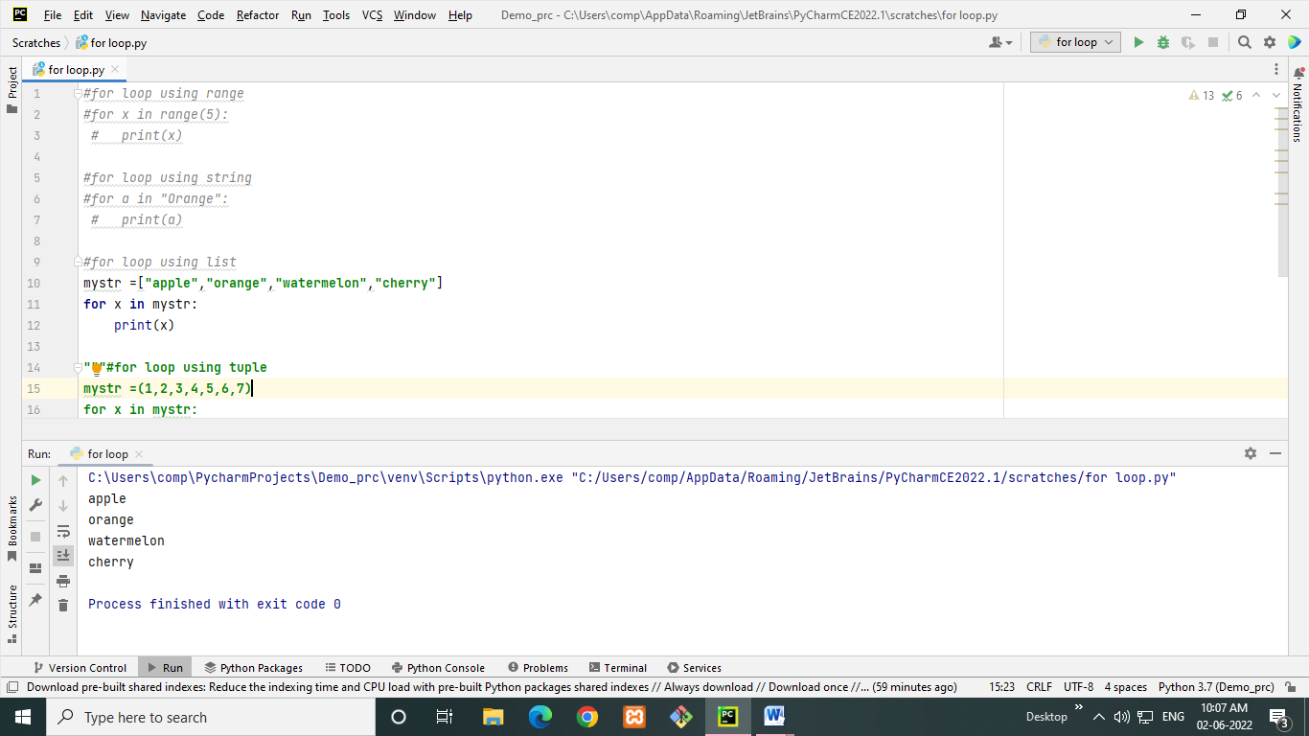

* **for loop using tuple**mystr =(1,2,3,4,5,6,7)  
  **for** x **in** mystr:  
   print(x)
* **Output:-**

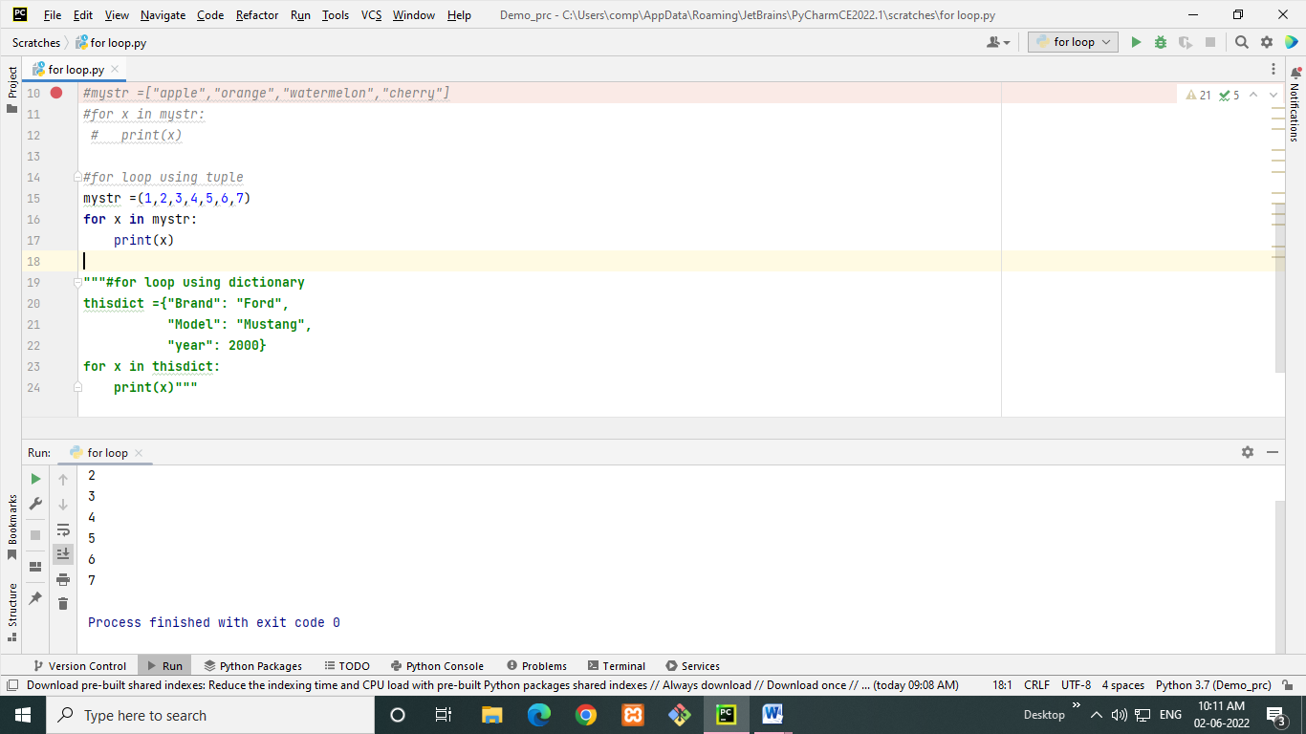

* **for loop using dictionary**thisdict ={**"Brand"**: **"Ford"**,  
   **"Model"**: **"Mustang"**,  
   **"year"**: 2000}  
  **for** x **in** thisdict:  
   print(x)
* **Output:-**

